**GLOBAL STRATEGY DEVELOPMENT AND**

**IMPLEMENTATION**

**Table of Contents**

Introduction 2

i. Analysis of the reasons for Tesco’s International expansion to Germany 2

Historical performance of Tesco 2

Service and product range of Tesco 3

Market share and competitive position of Tesco 3

ii. Strategic choice of Tesco 4

iii. Reasons for selecting Germany for the expansion 5

iv. Strategic method and entry mode of Tesco 10

v. Description of potential organizational& managerial problems for Tesco to operate in the new international environment 11

vi. Strategic advice for Tesco to overcome the problems 12

Conclusion 13

References 14

# Introduction

In this report, the global strategy of Tesco for the expansion of the business in Germany will be discussed in detail.

# i. Analysis of the reasons for Tesco’s International expansion to Germany

## Historical performance of Tesco

Tesco Plc. is one of the biggest retail companies in the United Kingdom which deals with Grocery products and other items as well as the brand value of the company is extremely impactful in the international expansion of the company In Germany. On the other hand, it may be revealed that Tesco plc. was founded by Jack Cohen in 1919 in the UK while it has been observed that the revenue of the company is increasing day by day (Tesco, 2021). Additionally, it needs to be opined that in 2018, the company has launched JACK’S which is a new brand and the main motive of the brand is to provide food items to customers at extremely low prices (Tesco, 2021).

In addition to that, the annual group sales of the company were £49.9 billion in 2020 which increased by 7.1% and in 2021 the annual group sales of Tesco is £53.4 billion which indicates the company has become profitable in recent years and is suitable for expanding into international markets such as Germany (Tesco, 2021). Furthermore, it has been observed that the company started in 1919 and is expanding day by day while the total number of employees of the company is 360,000 which indicates the starting position of the company in the UK market. Moreover, the successful approach of the management helps to open many branches in several European countries such as Czech Republic, Ireland, Hungary and Slovakia.

|  |  |  |  |
| --- | --- | --- | --- |
| **Historical Performance of Tesco** | **2021** | **2020** | **2019** |
| Group sales | £53.4 billion | £49.9 billion | £56.9 billion |
| Retail free cash flow | £1,187 million | £1,690 million | £889 million |
| Statutory revenue | £57.9 billion | £58.1 billion | £63.9 billion |
| Supplier satisfaction | 85% | 80% | 77.8% |

**Table 1: Market data of Tesco from 2019-2021**

(Source: Self-created)

## Service and product range of Tesco

It is required to be opined that Tesco provides a wide range of services and products which consists of food, garments, electronic gadgets and financial services while it has been observed that the company has decided to increase the variety of the products which will be extremely helpful for the expansion of the company in Germany. Additionally, as part of their research, Rosnizam et al. (2020) stated that Tesco mainly focused on providing food and beverages items although Tesco also provided the service and products at extremely low prices with maintaining the supreme quality of products which is one of the significant market strategies of Tesco. Moreover, the management of Tesco also launched a delivery saver plan for the prime customers, however, any customer may buy the daily saver plan for £7.99 in a month (Tesco, 2021).

## Market share and competitive position of Tesco

The share of the company is increasing day by day while it has been mentioned that the retail opening cash flow of the company was £3,757 million in 2020, however, due to the impact of the Covid-19, the retail opening cash flow was decreased by 3.2 % which affected the share of the company in the UK (Tesco, 2021). Due to the increases in sales the market share of the company is rising significantly and Tesco observed that the increase of sales by 15.1% and recorded the best growth in market share since June 2020 (Proactiveinvestors UK, 2021).

|  |  |
| --- | --- |
| **Porter’s five forces** | **Impacts of the forces in the expansion of Tesco in Germany** |
| **The threat of substitute products** | It has been observed that the threat of substitute products is high as well as the other companies of Germany may sell the same retail products. |
| **The threat of entry of new competitors** | There are many retail companies in Germany which indicates that as a start-up Tesco has to face these existing suppliers while the threat of new competitors is extremely high for Tesco in Germany |
| **Competitive rivalry** | The existing supplier of Germany may create lots of difficulties for Tesco whole competitive rivalry will be high for Tesco in Germany |
| **Bargaining power of buyers** | There are many existing retail companies in Germany who know  the way to control the bargaining power of buyers while Tesco needs to implement an effective policy to manage the bargaining power of buyers through implementing an effective pricing  strategy |
| **Bargaining power of suppliers** | It may be derived that the supply capacity is growing day by day in the retail industry which creates a lot of challenges for suppliers and impacted the growth of an organization through holding a specific authority over the suppliers (Wang *et al.,* 2018). Moreover, there are several international suppliers while the bargaining power of suppliers is also low for Tesco in Germany. |

**Table 2: Porter’s five forces**

(Source: Self-created)

# ii. Strategic choice of Tesco

The HRM of Tesco needs to focus on five things that are extremely essential in expanding the business in Germany such as product offering, value-added services, advanced marketing approaches and competitive moves which are the most impactful strategic choices that need to be executed by Tesco. Cohen and Eimicke (2020) have proposed that it is extremely important for the management of a company to make an effective strategic plan which is extremely essential to achieve the goals of the company in the future. According to Yip (1989), an organization needs to implement three strategic choices such as developing the main strategy, internationalizing the main strategy and globalizing the international strategy as these strategies are extremely impactful to expand the business in a fruitful way.

**Transnational Strategy**

Transitional strategy is extremely impactful in the international expansion of an organization while this strategy may create a positive impact to manage and handle the overseas operation of an organization. Moreover, it needs to be mentioned that the management of Tesco needs to select a joint venture which will help to mitigate the overall production cost as well as in the strategy the organization follows a decentralized organization structure.

**Multi domestic Strategy**

In a multi-domestic strategy, the organization focuses on the demand level of the local customer while in this strategy an organization may plan an effective sales planning which will help to make different types of products according to the demand of foreign customers.

**Global strategy and International strategy**

One of the main approaches of the international strategy is to give more focus on exports and imports which will help to conduct international trading while in this strategy an organization may operate the international business without establishing any branches of the organization in foreign countries. In addition to that, the international business strategy seals with several ownership and social ties which helps to maintain a healthy relationship between buyer and supplier in the international market (Holmes *et al.,* 2018). Moreover, global strategy is also helpful in doing business across national borders through increased sales in the global market.

# iii. Reasons for selecting Germany for the expansion

**Pestle analysis**

**Political factors**

It needs to be opined that the government of Germany is stable and also helped the organizations which is a positive factor for Tesco in expanding the business in that country.

**Economic factors**

The German economy is one of the fastest growing economies in the whole of Europe while due to Covid-19 the growth of the economy was affected. Moreover, it has been mentioned that the Gross National Income of the country is growing significantly and it has reached 46,980 US dollars in 2020 which will play an essential role in the expansion of the company in that country (Data.worldbank.org, 2021).

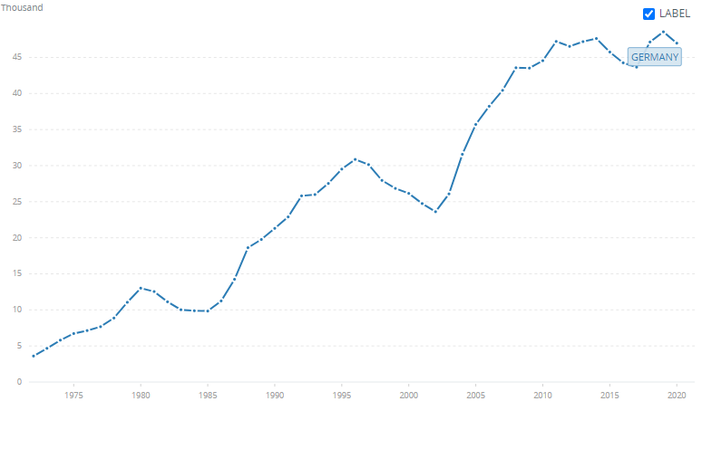

**Figure 1: GNI of Germany**

(Source: Data.worldbank.org, 2021**)**

**Social factors**

The population of Germany is also increasing which will be extremely helpful in the expansion of Tesco in that country as more population will enhance the target market of Tesco and resulted in the growth of the company.

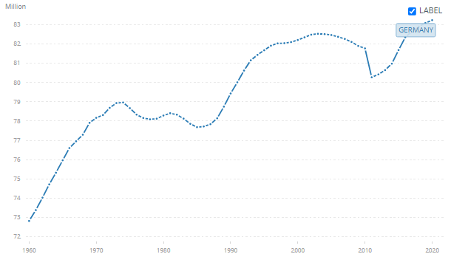

**Figure 2: Total population of Germany**

(Source: Data.worldbank.org, 2021**)**

**Technological factors**

Tesco needs to develop an Electronic Data Interchange system (EDI) to coordinate the flow of manufacturing materials, however, the technological advance of Germany will help Tesco in the expansion of the company in that country.

**Legal factors**

The legal environment of the country is extremely suitable due to adaptation of trade policies, international laws and regulations for the international expansion of Tesco while the management of the company needs to analyse the legal factors of the country.

**Environmental factors**

It will be noted that the government of the Germany is concerned about the emission of Carbon dioxide while in recent years the amount of Carbon dioxide emissions is decreased in a significant way and it was 776.61 Mt in 2018 which will extremely effective for the management of Tesco to expand the business in the country (Climatewatchdata.org, 2021).

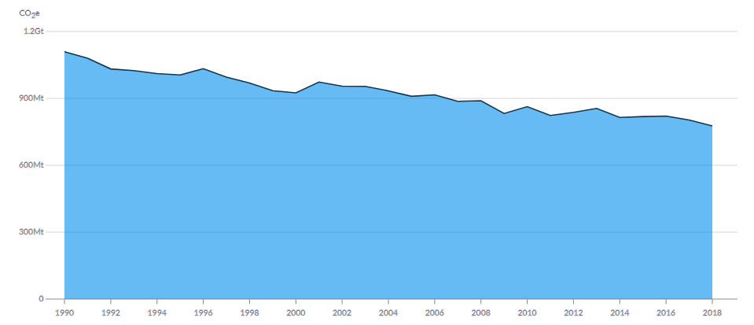

**Figure 3: Carbon dioxide emission of Germany**

(Source: Climatewatchdata.org, 2021**)**

**Porter's diamond model**

Porter's diamond model is one of the most popular models which is used to measure the competitive advantage of an organization which helps the management of the company to implement proper initiatives for the international expansion of the organization. On a specific note, porter diamond theory is based on national competitiveness which consists of four indicating factors such as factor conditions, related and supporting firms, demand conditions and structure, strategy and rivalry of an organization which plays a crucial role in operating an organization in a fruitful way (Vlados, 2019). In addition to that, another two factors or conditions were added which are also extremely impactful to measure the competitiveness of organizations such as government and chance.

**Factor Conditions**

Factor conditions are one of the most important factors which consist of capital, natural and human resources of an organization while the management of Tesco has lots of sufficient resources which creates a beneficial impact in increasing the competitive advantage of Tesco. Moreover, Tesco has lots of natural resources, as well as the production and manufacturing units of Tesco, are able to utilize natural resources. In addition to that, the sales of the company are increasing day by day which results in an increase in the annual income of Tesco and helps to provide sufficient capital resources which helps the company in international expansion in Germany. Moreover, it needs to be stated that the Human Resource Management (HRM) for the company is extremely effective to manage and handle all the operations of the company which is suitable for international expansion in Germany.

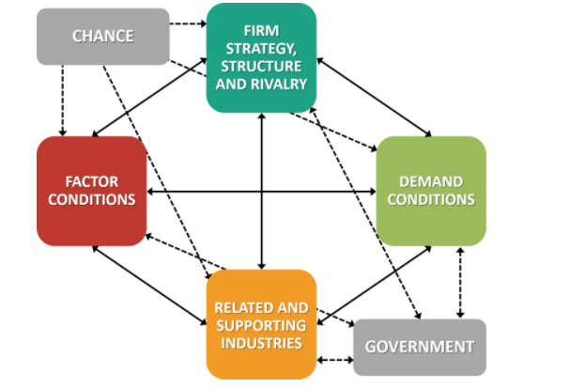

**Figure 1: Porter’s Diamond Model**

(Source: Vlados, 2019)

**Related and supporting industries**

It may be opined that the existence of related industries is extremely helpful in the international expansion of Tesco in Germany while there are lots of related industries in the national and global market of the organization. Additionally, supporting the industries of Tesco creates a beneficial impact which results in overall development in the business operations of Tesco which helps to enhance the competitive advantage in the global market. Apart from that, there are several global suppliers of Tesco which ensures the delivery of supreme raw material to the organization and helps to meet the satisfaction level of customers.

**Strategy, structure and Rivalry of Tesco**

The management of Tesco has implemented several effective strategies which help the company in the international expansion in Germany even though the joint venture may be extremely effective for the company in this global expansion. Moreover, it is required to be mentioned that the management of Tesco has to face several rivalries in the German Market such as Edeka, Rewe and Aldi. Moreover, it is extremely essential for the organization to implement the strategy of joint ventures which will help in the entry of Tesco into the German market.

**Demand conditions**

It has to be mentioned that the company is extremely popular in the UK while the customer base of the organization is extremely high in the domestic market which helps Tesco in this international expansion to Germany. In addition to that, the management of Tesco is extremely concerned with the demand level of customers while the company needs to recognize the behaviour pattern of customers which is extremely impactful in the expansion of the company in Germany.

**Government and Chance**

The Government of the UK needs to encourage and motivate the management of Tesco which will help in increasing the competitive advantage in the international market. Apart from that one of the main roles of the chance is to mitigate the impact of natural calamity and disaster even though the government and the organization do not have enough power to control these random events.

# iv. Strategic method and entry mode of Tesco

It needs to be stated that it is extremely important for the management of Tesco to implement a strategic entry method before expanding the business in Germany. On a contradictory note, it has been derived that the size of the market in Germany is extremely big which may create a positive impact in targeting the customers. Along with that, Tesco may choose early market entry or first-mover which will be suitable in expanding the business in Germany although it has some advantages such as it may increase the sales volume of the company in a fruitful way. Moreover, as part of their research, Wu et al. (2020) stated that it has been stated that there is a relationship between entry mode and innovative performance of an organization while it is extremely important for the organization to select a proper market before the entry.

It needs to be opined that the management of Tesco needs to choose the production in a foreign market which is one of the most significant entry modern of Tesco in the German market. On a similar note, it may be derived that the management of Tesco needs to implement a long-term strategic planning which will be extremely impactful for the prediction in the market of Germany. As part of their research, Shen et al. 2017 stated that it is one of the most essential decisions of an organization to implement an entry mode through selecting a foreign country while the organization may increase the engagement level in the foreign market by exporting products, joint ventures and establishing the firm in the foreign country. Moreover, it is required to be implied that it is extremely important for the management of Tesco to establish a joint venture in the market of Germany which may create a positive impact on the expansion of the business of Tesco in Germany. In addition to that, Tesco needs to target the customers of the country while it is extremely important for the company to establish a new production unit to anticipate the demand of customers in that country.

# v. Description of potential organizational& managerial problems for Tesco to operate in the new international environment

It needs to be stated that SWOT analysis is extremely effective to analyse the potential organizational and managerial problems of Tesco which will help the company to operate in the environment of Germany. Moreover, argument needs to be developed that Tesco is one of the biggest retail organizations in the world and it has several supermarkets all over the world while customer loyalty is one of the strengths of Tesco (Fatricia, 2017). One of the weaknesses which may be faced by Tesco is the quality issues at the initial stage, while it is required to be extremely difficult for Tesco to maintain the quality of products in the new environment of Germany.

**Organisational coordination**

It is extremely difficult for the management of Tesco to deal with the problem of organization coordination in Germany even though the company needs to promote effective initiatives to deal with these problems. On a specific note, one of the most significant ways to improve organizational coordination is to implement an informal communication channel as well as it helps to improve the flexibility of an organization through mutual adjustments (Westerberg, N. and Hansson, 2021).

**Cultural**

After analysing Hofstede's cultural model it has been derived that the masculine influence is moderate (66) in this country which may create issues in operating the entire business operation in Germany (Hofstede Insights. 2021). However, the long-term orientation is extremely high in the country which indicates that the management of Tesco needs to implement long term plans otherwise it may create several difficulties in operating the business in Germany. In addition to that, after analysing the model it has found that the uncertainty avoidance of Germans is 83 which indicates that the country does not have the proper capability to avoid uncertainty in the workplace.

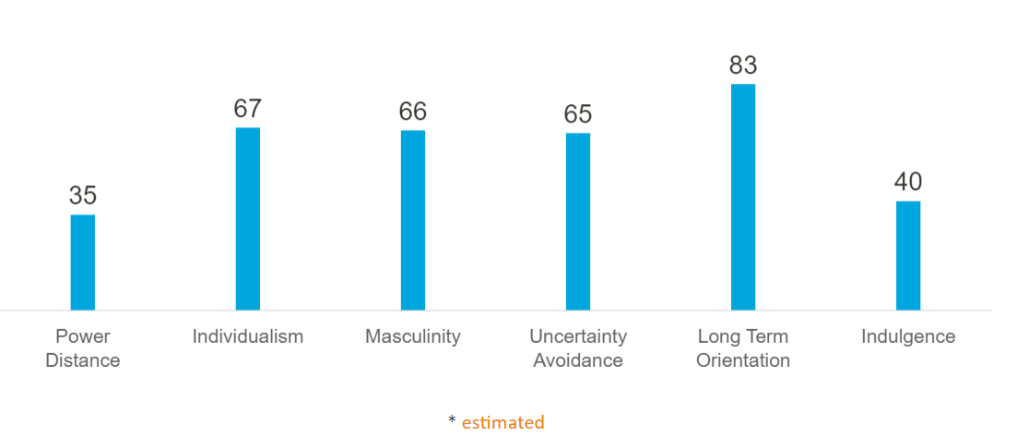

**Figure 2: Hofstede cultural model**

(Source: Hofstede Insights. 2021)

**Organisational structure**

The management of Tesco follows the decentralized structure which may create several challenges in doing business in Germany while one of the biggest disadvantages of decentralization is senior manager of the organization may not be able to control the entire business process of the company through the decision making process. Moreover, it is required to mention that in a decentralized organizational structure the manager of a company may not implement standardised strategies for cost savings (RAJA, 2021).

# vi. Strategic advice for Tesco to overcome the problems

The management of Tesco needs to implement proper initiatives which will help to resolve these issues even though it is the duty of the management of Tesco to implement proper strategies to solve these problems. On a broader note, the management of the company needs to establish effective communication which will be extremely useful to increase the organizational coordination. In addition to that, the management of the company requires to implement effective leadership styles which may create an essential role in handling the staff of the company and establish a healthy work culture which will be important for organizational coordination. Apart from that, Tesco needs to execute proper initiatives to increase the credibility of the employees in enhancing the capability to handle the pressure which will result in handling the potential to face unknown situations in the workplace. Additionally, it needs to be implied that the decentralized organizational structure also has some advantages such as senior managers of the organization may make the most important decisions as well as it empowers the responsibility of all employees which will be extremely useful in the international expansion of the company in German.

# Conclusion

From the above discussion, it may be concluded that global strategy is extremely important in the international expansion of the company by create an effective global strategy.

# References

Climatewatchdata.org. 2021. *| Greenhouse Gas (GHG) Emissions | Climate Watch*. [online] Available at: <https://www.climatewatchdata.org/ghg-emissions?chartType=area&end_year=2018&regions=DEU&start_year=1990> [Accessed 29 July 2021].

Cohen, S. and Eimicke, W.B., 2020. 7. STRATEGIC PLANNING. In *Management Fundamentals* (pp. 93-102). Columbia University Press.

Data.worldbank.org. 2021. *GNI per capita, Atlas method (current US$) - Germany | Data*. [online] Available at: <https://data.worldbank.org/indicator/NY.GNP.PCAP.CD?locations=DE> [Accessed 29 July 2021].

Fatricia, R.S., 2017. STRATEGIC ANALYSIS OF TESCO SUPERMARKET. *JurnalManajemenTerapan dan Keuangan*, *6*(2), pp.69-86.

Hofstede Insights. 2021. *Country Comparison - Hofstede Insights*. [online] Available at: <https://www.hofstede-insights.com/country-comparison/germany/> [Accessed 5 August 2021].

Holmes Jr, R.M., Hoskisson, R.E., Kim, H., Wan, W.P. and Holcomb, T.R., 2018. International strategy and business groups: A review and future research agenda. *Journal of World Business*, *53*(2), pp.134-150.

Proactiveinvestors UK. 2021. *Tesco increases grocery market share for first time in four years*. [online] Available at: <https://www.proactiveinvestors.co.uk/companies/news/942686/tesco-increases-grocery-market-share-for-first-time-in-four-years-942686.html> [Accessed 29 July 2021].

RAJA, N., 2021. *centralisation and decentralisation*. [online] Academia.edu. Available at: <https://www.academia.edu/17216162/centralisation_and_decentralisation> [Accessed 5 August 2021].

Rosnizam, M.R.A.B., Kee, D.M.H., Akhir, M.E.H.B.M., Shahqira, M., Yusoff, M.A.H.B.M., Budiman, R.S. and Alajmi, A.M., 2020. Market Opportunities and Challenges: A Case Study of Tesco. *Journal of the Community Development in Asia (JCDA)*, *3*(2), pp.18-27.

Shen, Z., Puig, F. and Paul, J., 2017. Foreign market entry mode research: A review and research agenda. *The International Trade Journal*, *31*(5), pp.429-456.

Tesco, 2021. [online] Available at: <https://www.tesco.com/> [Accessed 29 July 2021].

Vlados, C., 2019. Porter’s diamond approaches and the competitiveness web. *International Journal of Business Administration*, *10*(5), pp.33-52.

Wang, Y., Tang, W. and Zhao, R., 2018. Information sharing and information concealment in the presence of a dominant retailer. *Computers & Industrial Engineering*, *121*, pp.36-50.

Westerberg, N. and Hansson, O., 2021. Coordination Challenges in Scaled Agile.

Wu, C., Huang, F., Huang, C. and Zhang, H., 2018. Entry mode, market selection, and innovation performance. *Sustainability*, *10*(11), p.4222.

Yip, G.S., 1989. Global strategy... in a world of nations. *Sloan management review*, *31*(1), pp.29-41.