**Question 1)**

In the UK there are not many supermarket options other than the four big ones. Though there are many small options but only Asda, Tesco, Sainsbury and Morrisons are the big ones there. Their policy of work is almost same and that is why each of them knows what each other is going to do in the future. Structure of the supermarket chain in UK will be analyzed in this essay. Their perspective of development of the consumers and their profit structure will also be discussed here.

“Market Structure” is basically the features of a market. The supermarket chains of the UK focus a lot on these structures as “market structure” plays a huge role in many factors like “degree of competition”, “pricing decisions”, and “service quality” etc.

In order to handle “competition” properly they target their customers. Based on their customer segmentation they make slight changes in their products or in their marketing strategy. This route is followed by many other big companies as well. For an example, Apple Inc. makes phones for a wide range of prices. From 400 dollar to 1400 dollar they have options to tackle their biggest competitors.

As there are not many options for the people there can be a congestion of “monopoly” for these supermarket chains. These supermarket chains can differentiate their customers based on different price category. In some of the cases, the supermarket chains can introduce something new into the table and can charge a hefty amount for the same. These companies are accused of being a monopoly (Antonenkov *et al.* 2018). They have built stores across the countries but at the same time they have competitors on those markets that were preexisted. But they still managed to gain a lot in these locations as well.

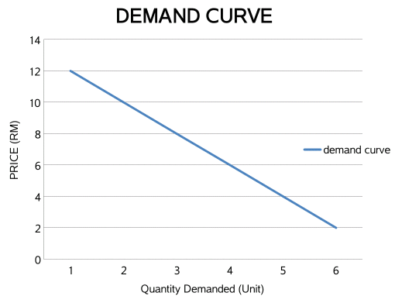

**Figure 1: demand curve of Tesco**

(Source: allbouttesco.blogspot.com)

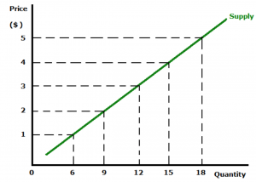

**Figure 2: supply curve**

(Source: studyrocket.co.uk)

There are many factors of demand of those supermarket chains. Here are some of them: “price of services”, “health awareness of the goods”. For example, the supplier will decrease the prices of the goods and services when the demand is not that high.

Customer Welfare can be brought into the table in many ways. In some cases, for example, in festivals these chains introduce a lot of discounts and offers (Greenwood *et al.* 2018). They offer home delivery at the doorstep of customers without any extra charge. Customer satisfaction has been identified as the key way to succeed.

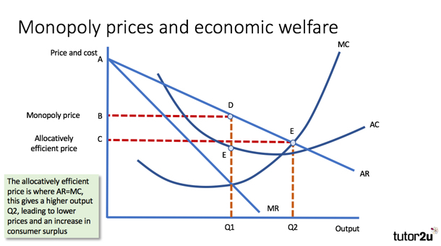

**Figure 3: Economic welfare**

(Source: www.tutor2u.net)

The suppliers can see a profit in a long run only if they can maintain few things such as “reducing cost”, “increasing productivity” and “increasing efficiency”. Expanding the market and spending effectively will also allow the suppliers to gain profit. They can target their area of high profits and make adjustment according to that.

Therefore it is seen that the competition among the supermarket chains in the UK. Only 3 to 4 big supermarket chains are there and they know each other’s policy of business. Market structure of the chains is described here. The features of long term profit are also described in this essay.

b) When a new supermarket chain decides to take entry they have to think about a lot of things even before stepping in.

* The lack of having a strong “brand identity” is the biggest issue for the newbie.
* It is almost impossible to gain “customer loyalty” from day one.
* The issue of licenses at the beginning of the business.
* “External tax issues” is also a big barrier for their success.

Having more suppliers means the company does not need to depend on one supplier. If anything happens to a particular supplier, the supply chain would not stop. On the other hand the customer can use his or her bargaining power.

c) With the growing competition in the online marketplace the supermarket chains are thinking differently. They have to set obvious goals to tackle the big online brands. They have proposed a concept of having “premium store”. This is their long term goal and they do not want to make that plan happen in near future. They have also identified to give more importance in acquiring some of the smaller companies to expand their business. This is their medium term future. They can also identify the areas where the customers are not happy and continue to work on that. They can see this as a short term goal.

# Question 2)

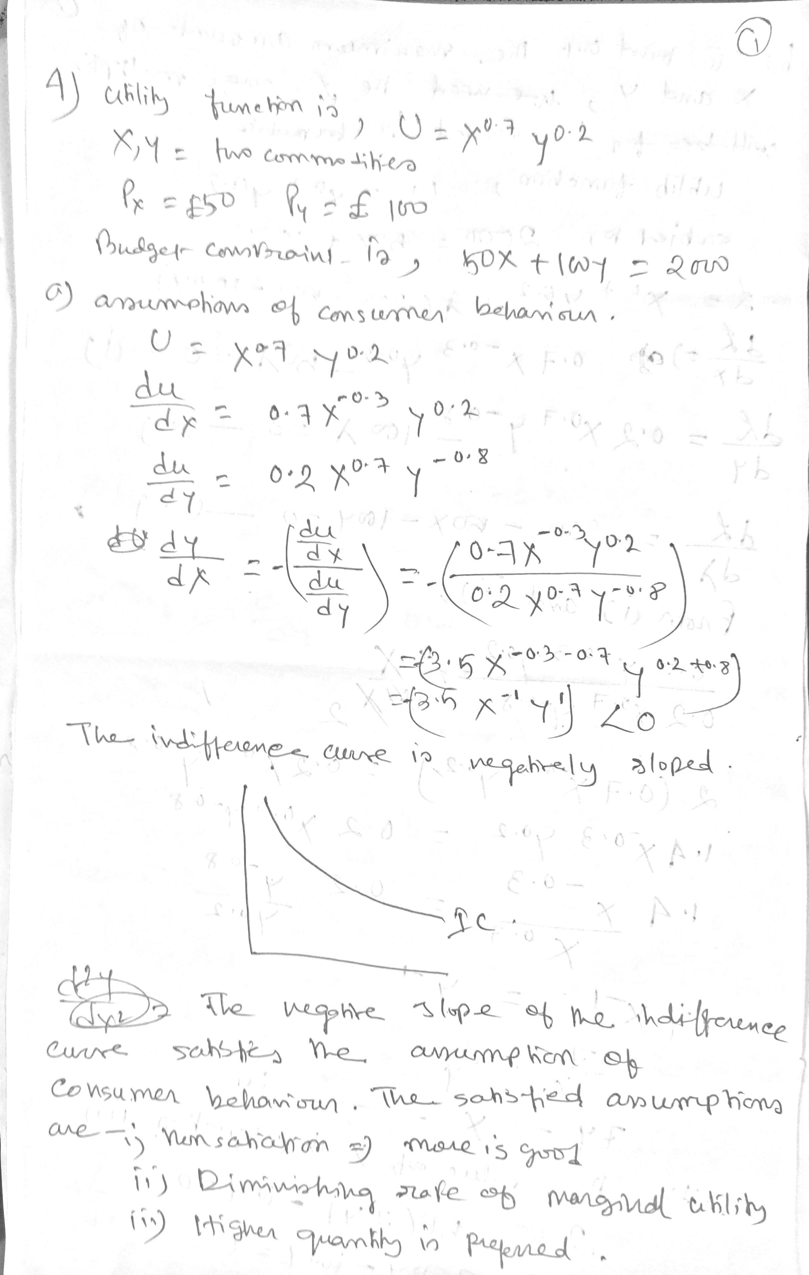





**Question 3)**



